**Product Manual: Adapted Limit Switch**

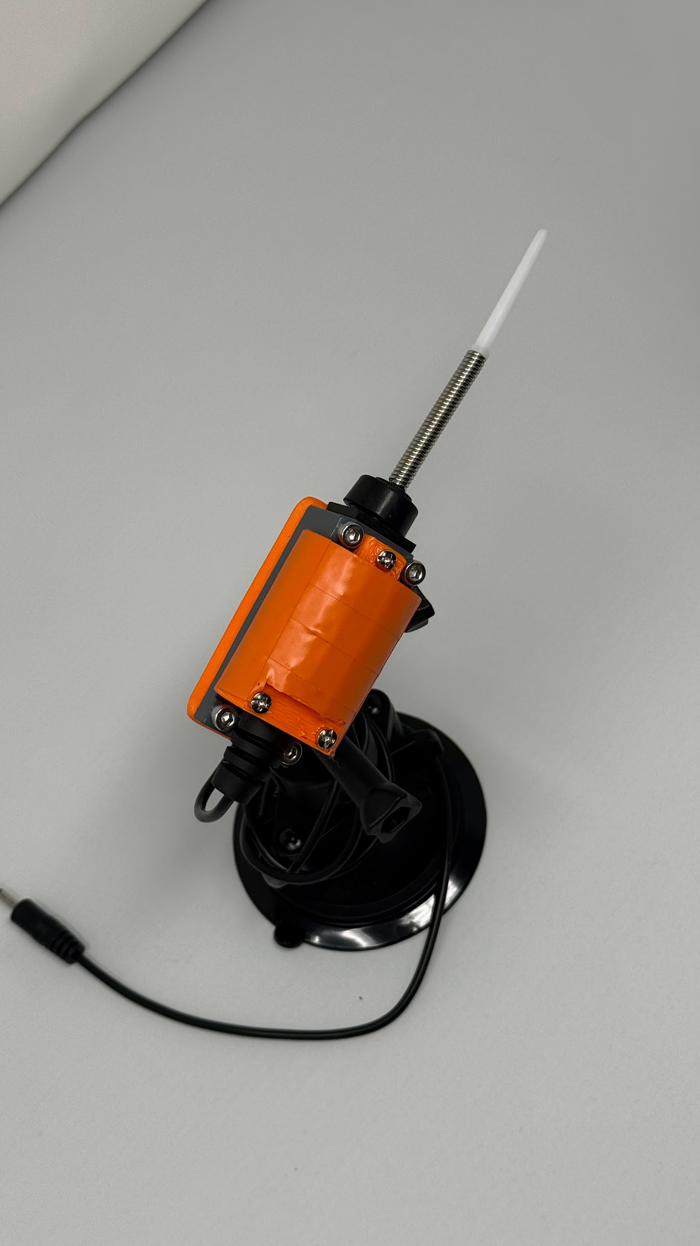



Revision: 1.0

Date: 03-Dec-2025

# **Table of Contents**

**Table of Contents 1**

**1. Introduction 2**

1.1 About the Community Partner 2

1.2 Product Description 3

WHY? 3

WHO? 3

WHAT? 3

HOW? 3

1.3 Product Overview and Features 4

1.4 Bill of Materials (BOM) 5

**2. User Guide: Instructions for Use 6**

2.1 Set Up Instructions 7

2.2 Maintenance 10

2.3 Troubleshooting 10

**3. Maker Guide: Assembly Instructions 11**

3.1 Assembly Guide 12

**4. Credit and Open Hardware Licence 15**

4.1. Open Hardware Attribution 15

4.2. License Statement and Source Availability 16

4.3 CERN Open Hardware Licence 16

# **1. Introduction**

## 1.1 About the Community Partner

Our journey began in 1970 with the will of Mrs Shakuntala Bhatia. Under the banner of the Asian Women’s Welfare Association, Mrs Bhatia and her peers, like Mrs Tambyah and Mrs Kula, identified gaps in the community to help the underserved.

The Association incorporated AWWA Ltd on 7 January 2015, a Singapore company limited by guarantee. In April of the same year, AWWA Ltd took over the operations and activities previously managed by the Association. In 2022, the Association was dissolved, and AWWA continues to address social service gaps as they arise, by being guided by our mission and strategic vision.



## 1.2 Product Description

This table clarifies the intended purpose and scope of the product:

| **WHY?** | Special needs students with low mobility are often excluded from using toys and/or face lack of appropriate ways to express themselves. |
| --- | --- |
| **WHO?** | For special needs students with low mobility who are learning to understand cause-and-effect and have fun. |
| **WHAT?** | A limit switch with an additional 3.5mm male mono audio cable to trigger the power of other toys or play back audio. 3D printed casing with camera mounting hole for easy install clamp and mount on the wheelchair |
| **HOW?** | This product transforms an off-the-shelf limit switch into a durable and responsive device that triggers power on/off other toys or playback audio and an easy mounting mechanism . It allows students to use the limit switches to experience and understand the cause-and-effect. |

## 1.3 Product Overview and Features

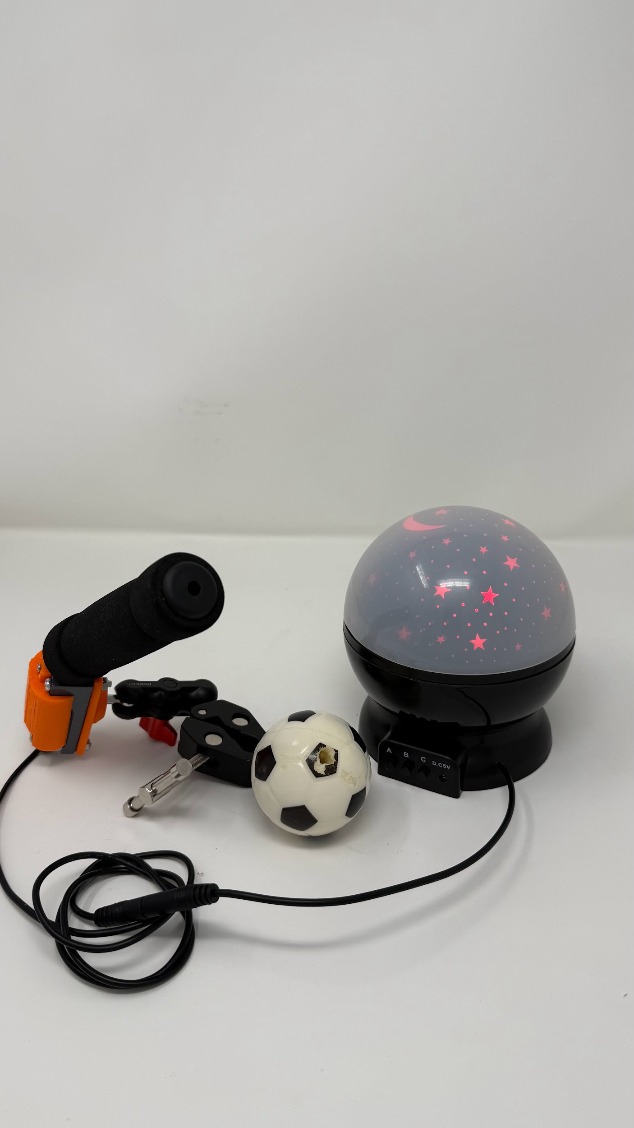

1. Adapted Limit Switch support push in all directions to trigger. Left, right, up or down it can be triggered.
2. Add-on soft ball, soft bicycle handle or soft toy to trigger stick to make it more interesting to students to try it out.
3. Can support different types of mounting or clamp system with standardised camera mount.
4. Connect to other electronic toys with a female 3.5mm mono audio jack cable.

## 1.4 Bill of Materials (BOM)

| **Item** | **Supplier/Product Link** | **Price** | **Quantity** |
| --- | --- | --- | --- |
| 3D printed top part | Pending for stl file |  | 1 |
| 3D printed bottom part | https://3dprintsingapore.com/ | 2.77 SGD/pcs | 1 |
| Limit switch | [Click Here](https://www.amazon.sg/uxcell-a13051100ux0165-ME-8169-Flexible-Spring/dp/B00D83C54U/ref=sr_1_1?crid=3ZJER872RBO4&dib=eyJ2IjoiMSJ9.Rv3E55iLr8ZS46NzW7vYEKz2kbAHqt_QiPqYo5Nzj3TGjHj071QN20LucGBJIEps.CjveQYyoO6fqfCLMCIIXIPzUomEd0elLCvWrHXIwkUc&dib_tag=se&keywords=me-8169&qid=1764741496&sprefix=ME-816%2Caps%2C536&sr=8-1) - Link to long | 22.08 SGD | 1 |
| 3.5mm male mono audio jack cable | [Click Here](https://shopee.sg/10Pcs-Replacement-Male-Plug-to-Bare-Wire-Open-End-TS-2-Pole-Mono-1-8inch-3.5mm-Plug-Jack-Connector-Audio-Cable-Repair-i.215193340.21778408921?extraParams=%7B%22display_model_id%22%3A214202406805%2C%22model_selection_logic%22%3A3%7D&sp_atk=b81db4ed-1580-44d4-9bc4-45ea63a15642&xptdk=b81db4ed-1580-44d4-9bc4-45ea63a15642) - Link too long | 5.42 SGD/10pcs | 1 |
| M3 x 20mm partially threaded screw | [Click Here](https://shopee.sg/product/290986923/23552786540?gads_t_sig=VTJGc2RHVmtYMTlxTFVSVVRrdENkY0N5akVpcE5OamJEdjRRTHBOTzhma1VJallGRE04M1NjN3d6bFlMbnY2dEYzd20xVFNJRDhDaEJIOHI2TUVwYXI0L0g2YVkwVlhJOTFnSXVyNVYyam5YQzA1WXhhdkc2MEdHcVpWMnBEbnE&gad_source=1&gad_campaignid=1690731353&gbraid=0AAAAADPpRQQDOvlGlyyBvjhPYEgx3VecY&gclid=Cj0KCQiAi9rJBhCYARIsALyPDtstpJfIaovVRHUDaoqEkdTK7AFuBXPUFgrnLiwINphSN_mpzGyNizYaAkagEALw_wcB) - Link too long | 6.16 SGD/3pcs | 2 |
| M3 x 6mm screw | [Click Here](https://shopee.sg/20pcs-lot-M3-M4-M5-6-8-10-16-20-25-30-35-40mm-ISO7380-304-Stainless-Steel-Hexagon-Socket-Button-Head-Screw-Metric-Screws(-not-inch-screws)-i.428423619.9280341982?extraParams=%7B%22display_model_id%22%3A46521843952%2C%22model_selection_logic%22%3A3%7D&sp_atk=da4b9686-5e8c-408f-8bd6-ffe43ec625a8&xptdk=da4b9686-5e8c-408f-8bd6-ffe43ec625a8) - Link too long | 1.80 SGD/pcs | 1 |
| M4 x 16mm bolt | [Click Here](https://shopee.sg/product/910746909/22514432449?gads_t_sig=VTJGc2RHVmtYMTlxTFVSVVRrdENkY0N5akVpcE5OamJEdjRRTHBOTzhmbUIzS2h3OWtaUjEvTk5nMEdiS0NYckFUTVljRURHQVk0a3lDZTAvSi8vRkYxampxSnVFclU2UGlIcTRsRk13aW8vUHF3bmxUemNkYmN0d3krbnBFMXc&gad_source=1&gad_campaignid=1690731353&gbraid=0AAAAADPpRQQDOvlGlyyBvjhPYEgx3VecY&gclid=Cj0KCQiAi9rJBhCYARIsALyPDtsIc-h158gr0b4xVhEFBpAlCCl5VW2jvOMPvUy1644OBxxToPnco5gaAu3DEALw_wcB) - Link too long | 1.67 SGD/5pcs | 2 |
| M4 x 30mm bolt | [Click Here](https://shopee.sg/product/910746909/22514432449?gads_t_sig=VTJGc2RHVmtYMTlxTFVSVVRrdENkY0N5akVpcE5OamJEdjRRTHBOTzhmbUIzS2h3OWtaUjEvTk5nMEdiS0NYckFUTVljRURHQVk0a3lDZTAvSi8vRkYxampxSnVFclU2UGlIcTRsRk13aW8vUHF3bmxUemNkYmN0d3krbnBFMXc&gad_source=1&gad_campaignid=1690731353&gbraid=0AAAAADPpRQQDOvlGlyyBvjhPYEgx3VecY&gclid=Cj0KCQiAi9rJBhCYARIsALyPDtsIc-h158gr0b4xVhEFBpAlCCl5VW2jvOMPvUy1644OBxxToPnco5gaAu3DEALw_wcB) - Link too long | 1.90 SGD/5pcs | 2 |
| M4 nut | [Click Here](https://shopee.sg/M1-M1.2-M1.4-M1.6-M2-M2.5-M2.6-M3-M3.5-M4-M5-M6-M8-M10-M12-M14-M16-M18-M20-M22-304-Stainless-Steel-Hex-Hexagon-Nut-i.910746909.18572336942?extraParams=%7B%22display_model_id%22%3A137365476263%2C%22model_selection_logic%22%3A3%7D&sp_atk=a56c9875-9928-4a2f-a180-1b97ba8850d2&xptdk=a56c9875-9928-4a2f-a180-1b97ba8850d2) - Link too long | 1.87 SGD/20pcs | 4 |
| M5 Tee nut | [Click Here](https://shopee.sg/product/910746909/22637859537?gads_t_sig=VTJGc2RHVmtYMTlxTFVSVVRrdENkY0N5akVpcE5OamJEdjRRTHBOTzhmbUIzS2h3OWtaUjEvTk5nMEdiS0NYcnJQZXE4bDFiMWtLRmdCZDR5R2lxVXBJRkpxcTc5UStzS2pHRkR4c29QYXhPRG1tdlIwUjlBUTRJZU5IRUJ4NDY&gad_source=1&gad_campaignid=20231043599&gbraid=0AAAAADPpRQTabMCeDinif6mBCSCCEaIFe&gclid=Cj0KCQiAubrJBhCbARIsAHIdxD9xAaM_woq0_BLrA2Kd06gqUt0RaeSuJCmVliDqdSD44jUsud_NozIaAiJPEALw_wcB) - Link to long | 1.41 SGD/10pcs | 1 |
| Bicycle soft handle grip | <https://shop.daisosingapore.com.sg/products/4550480051574> | 2.18 SGD/2pcs | 1 |
| Soft ball | [Click Here](https://shopee.sg/Decompression-PU-ball-sponge-pressure-ball-toy-i.156491018.21284295277?extraParams=%7B%22display_model_id%22%3A98786858876%2C%22model_selection_logic%22%3A3%7D&sp_atk=042a6af9-0deb-40a7-88a1-15240c87d4bb&xptdk=042a6af9-0deb-40a7-88a1-15240c87d4bb) - Link to long | 0.73 SGD/pcs | 1 |

# **2. User Guide: Instructions for Use**

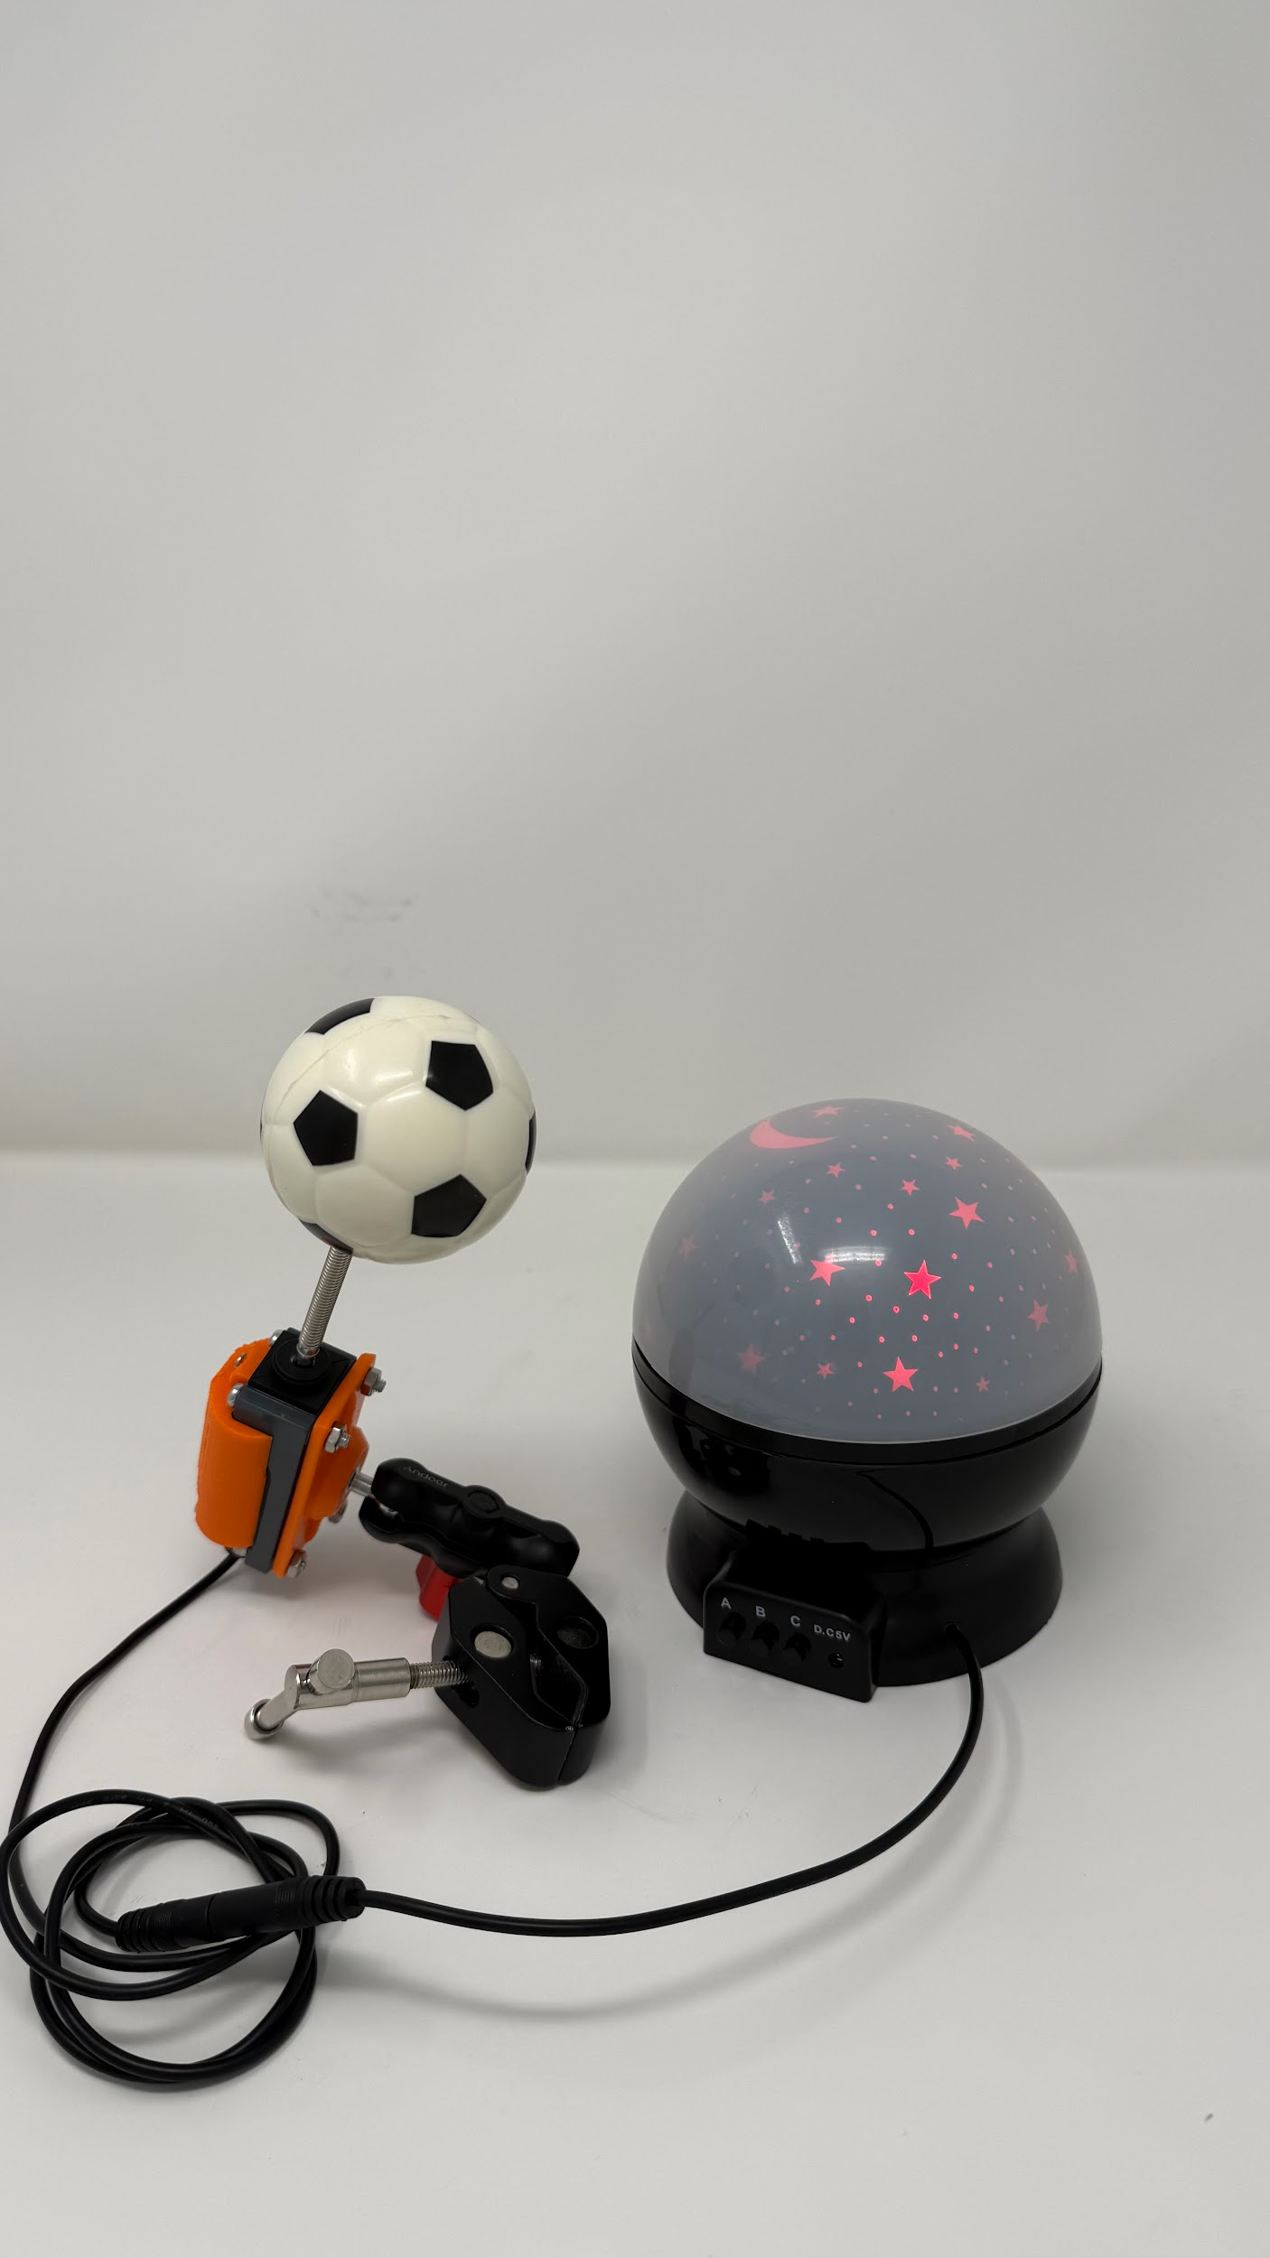

## 

## 

## 

## 

## 2.1 Set Up Instructions

Use the following table for a step-by-step guide to setting up the product:

| **Setting up** | |
| --- | --- |
| Push the white or spring to the left or right to trigger it. |  |
| Connect the 3.5mm male mono audio jack cable to toys |  |
| Suction cup mount. Secure the device properly by pushing the locking lever at the bottom side of the mount. It should be used on a flat surface. |  |
|  |
| Clamp mount. Secure the device properly by turning the big knob and change the angle with the small knob on the mount. It is mostly used on a wheelchair. |  |
|  |
| Gooseneck mount. Secure the device properly by squeezing the clip part and the gooseneck can adjust the angle. It is mostly used on a wheelchair. |  |
|  |  |

## 2.2 Maintenance

1. Check the clamp mounting if it is loose.
2. Check the 3.5mm male mono audio jack cable if it is loose or damaged.

## 2.3 Troubleshooting

| **Problem** | **Possible Cause** | **What You Can Try** |
| --- | --- | --- |
| The clamp or mount is loose so didn’t trigger toy | Didn’t clamp or mount properly | Read user guide on how those clamp and mount works |
| Not triggering the toy even is mounted properly | Toy issues | Check on the Toy product manual |
| Limit switch connection broken | Open with the assembly instruction and try to check on it or contact EG for support. |

### 

# **3. Maker Guide: Assembly Instructions**

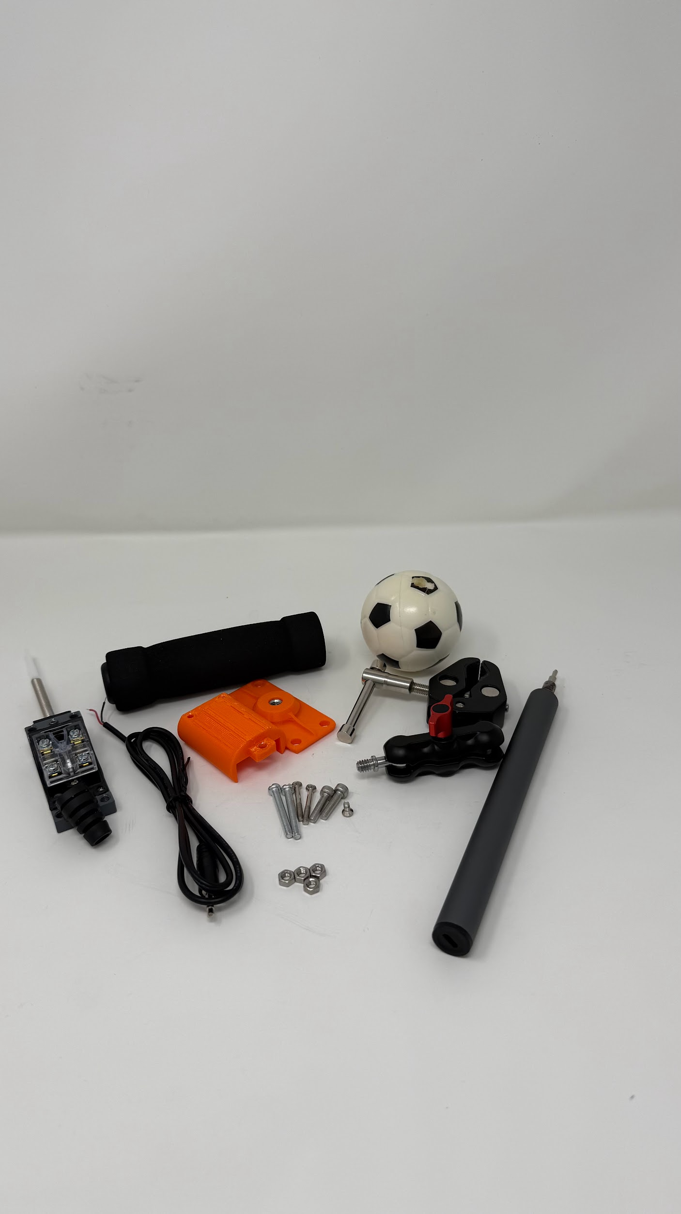

## 

## 3.1 Assembly Guide

| **Steps** | **Images** |
| --- | --- |
| Remove all the 3 screws from the limit switch. |  |
| Put the 3.5mm male mono audio jack cable through the flexible strain relief. |  |
| Unscrew the top 2 “NO” screws until the wire from the 3.5mm male mono audio jack wire can go through it. |  |
| Screw back the top 2 “NO”. |  |
| With the 3D printed bottom part and insert the tee nut into the hole on the flat side and use a M5 bolt to screw so the tee nut will bite into the 3D printed part. |  |
| With the 3D printer top and cover up the limit switch and screw the 3 screw and 4 bolt/nuts. |  |
| Screw the different mount or clamp into the bottom tee nut. |  |
| Test with a toy to see if it works. |  |

# **4. Credit and Open Hardware Licence**

This section provides the required legal notices and attribution for the open hardware design used to create this product.

## 4.1. Open Hardware Attribution

The core design for this Adapted Limit Switch is based on the Open Wobble Switch, an open-source assistive technology project.

* Original Designer: Makers Making Change (a program of Neil Squire).
* Original Copyright: Copyright (c) Neil Squire / Makers Making Change.
* Original Source Location: The original project source files are available online at: <https://www.makersmakingchange.com/product/open-wobble-switch/01tJR000000698oYAA>

## 

## 

## 4.2. License Statement and Source Availability

The hardware design used in this product is licensed under the CERN Open Hardware Licence Version 2 – Weakly Reciprocal (CERN-OHL-W 2.0) or later.

By distributing this product, we are obligated to make the complete design source available to you.

* Complete Source Availability: The complete design files (Source), including schematics, assembly instructions, and any modifications made by Engineering Good, are available free of charge at a permanent online location: <https://github.com/Engineering-Good/T4G-Adapted-Limit-Switch>
* Modification Notice: This version of the Adapted Limit Switch design was modified by Engineering Good to include the 3.5mm mono audio jack functionality for triggering other toys. The full, modified source is available at the URL listed above.
* Full License Text: The complete legal text of the CERN Open Hardware Licence Version 2 – Weakly Reciprocal** follows this section.

## 4.3 CERN Open Hardware Licence

The full text of the license is available here: [CERN-OHL-W 2.0 Full Text](https://gitlab.com/ohwr/project/cernohl/-/wikis/uploads/82b567f43ce515395f7ddbfbad7a8806/cern_ohl_w_v2.txt)